WEC-Sim Demo Test from Prof. Lin

## General:

1. NOTED:   
   Need user manual
2. COMPLETED:   
   Confusing on the “Run Button” in the SimMechanics interface. User cannot use the “Run Button”. It will give an incorrect and unstable solution because of the way we adjust the mass matrix to incorporate the add mass to avoid algebraic loop.
3. COMPLETED:   
   Need to have a better description to clarify the difference between “Constraints” and “Joints” in the WEC-Sim Component library.
4. NOTED:   
   Change the name of translational joint from “Heave (translational) joint” to “Translational joint”.

## Minor:

1. NOTED:   
   Clean up and add output for the joint, such as response and reaction force (Note that reaction force option is the new option given in version 2014a)
2. COMPLETED:   
   Option for calculating the forces on the body (similar to what OrcaFlex did)
3. NOTED:   
   Clean up input file, such as the first (clean var) section, the run simulation section and “simu.mode” part.

## Issues:

1. COMPLETED:  
   Bug find on Hydrodynamics Model:

The high and low peaks are generated by the time lag of added mass term. The calculation of backward extrapolation for the acceleration used for the added mass matrix was not correct.

Problem: High and low peaks for the square of pitch response (dt=0.05 sec)

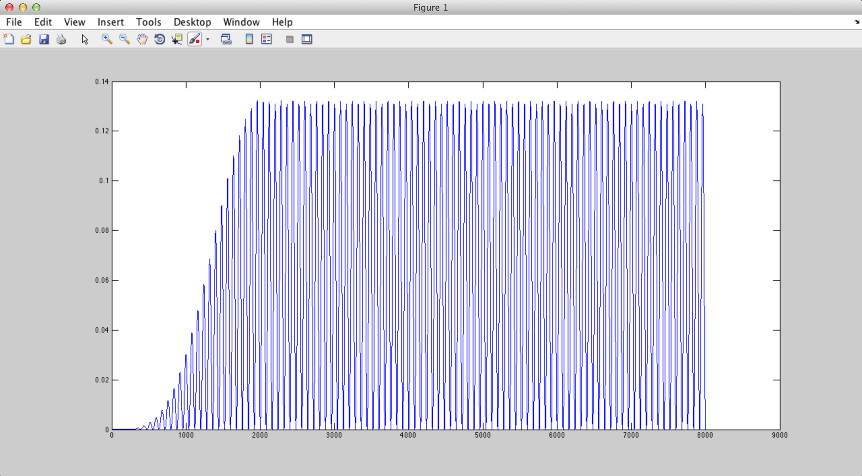

Cause:

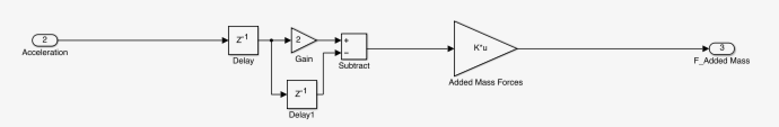

The correct formula and the correct model should be:

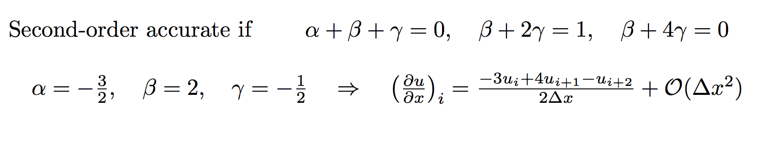

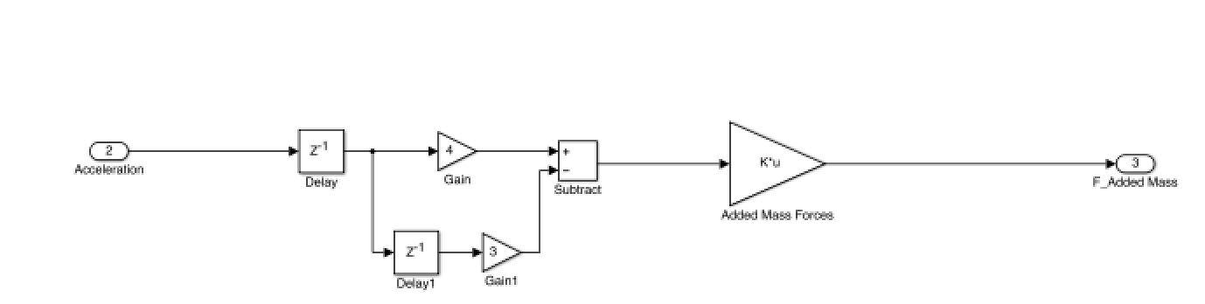

Result (pitch response square) after fixing the model (dt=0.05 sec):

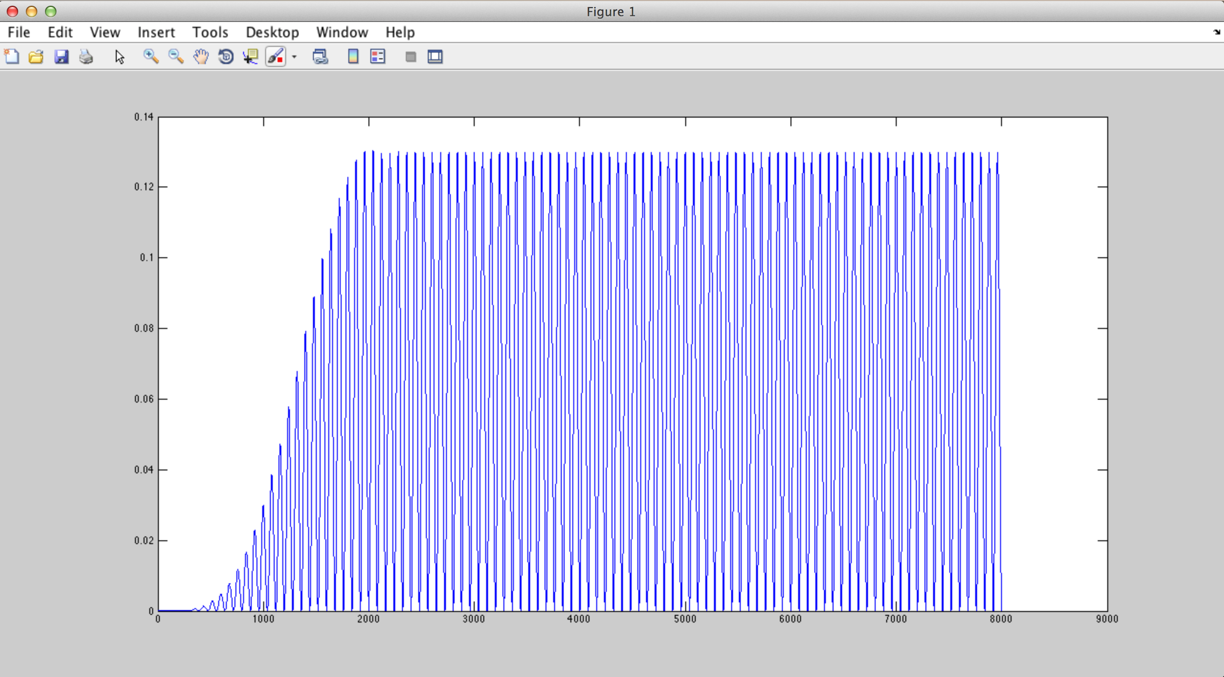

1. NOTED:   
   Issue on creating a more realistic flapper WEC system.   
   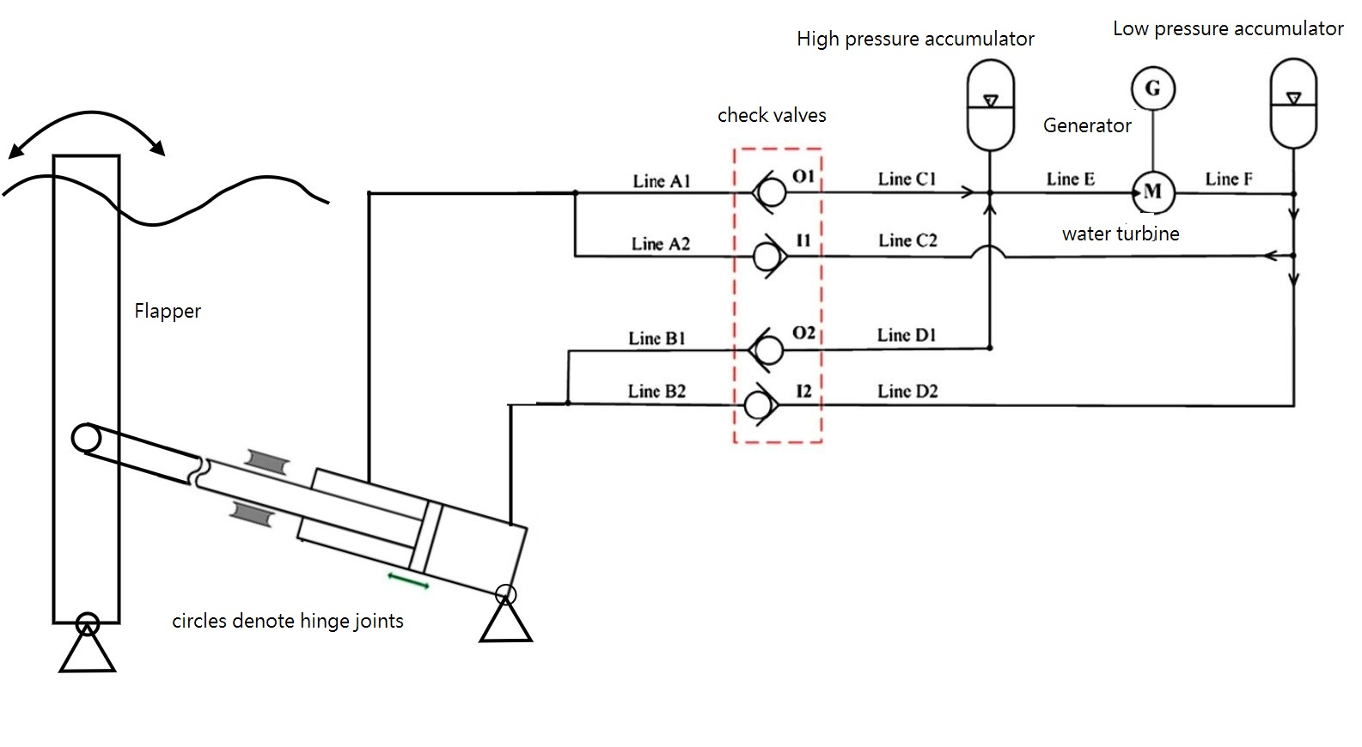

Simplified WEC-Sim Model:

|  |  |
| --- | --- |
| Did not work:  Macintosh HD:Users:yyu:Desktop:Screen Shot 2014-04-28 at 11.19.45 AM.png | Did work:  Macintosh HD:Users:yyu:Desktop:Screen Shot 2014-04-28 at 11.21.16 AM.png  The inertia has a mass value of 10e-6 kg. It started to become unstable using a mass smaller than 10e-6 for this case.  We may want to ask MATLAB to explain why |